
MAIN LEAK AND REPAIR PROGRAM
For Public Drinking Water Systems

Missouri Safe Drinking Water Regulations require all public water systems to disinfect all new, cleaned, or repaired water mains and include detailed procedures for the adequate flushing, disinfection, and microbiological testing of all water mains. All public water systems are required to maintain a minimum positive pressure of twenty pounds per square inch (20 psi) throughout the distribution system under all normal operating conditions. All water lines, pipes, and equipment which convey or store potable water must be disinfected in accordance with current AWWA Standards. The purpose of the Main Leak and Repair Program is to ensure distribution system repairs are adequately conducted and that inconvenience and sanitary hazards to customers will be minimized during repairs and emergency maintenance. Having a written and formalized Main Leak and Repair Program benefits the water system by ensuring compliance with the regulations and ensuring new operators, contract operators, back up operators from other water systems, and/or excavating contractors understand how your water system expects water distribution repairs and emergency maintenance to be performed.

The Main Leak and Repair Program was developed to assist water systems in meeting minimum regulatory requirements associated with distribution system repairs, emergency maintenance, flushing, public and department notification, sampling, and boil advisories and orders. The Main Leak and Repair Flow Chart provides guidance on necessary actions the water system should take during distribution system repair and emergency maintenance to ensure compliance with the Missouri Safe Drinking Water Regulations. It is the responsibility of the water system to ensure that all chemicals, coatings, valves, hydrants, flush outs, pipes and other appurtenances used by the water system are approved for drinking water use and conform to the department’s standard.

For more information regarding department standards on materials and construction standards refer to the Design Guide for Community Water Systems. For more information regarding boil advisories and boil orders refer to the Boil Order Manual. Both are located at www.dnr.mo.gov. This program also includes the following worksheets and guidance to assist water systems:

- Main Leak and Repair Flow Chart
- Boil Advisory Information Sheet
- Report of Low Water Pressure
- Discharging Chlorinated Water Best Management Practices
- Boil Advisory Door Hanger

If a boil advisory is issued or pressure drops below 20 psi during distribution repairs or emergency maintenance, the water system should complete the necessary forms and fax them to the following:

Kansas City Regional Office
Public Drinking Water Unit
(816) 622-7044

A copy of this plan and the other procedures should be easily accessible to all staff performing distribution repairs and emergency maintenance. This plan must also be made available to the department upon request.

This program does not include safety procedures for trenching and shoring or spare part management, operator training, and budgeting control for distribution repairs and emergency maintenance. The water system should develop comprehensive procedures to ensure distribution repair and emergency maintenance is conducted safely, that equipment and necessary parts are available, operators and other personnel are adequately trained, and that the water system has necessary funds.

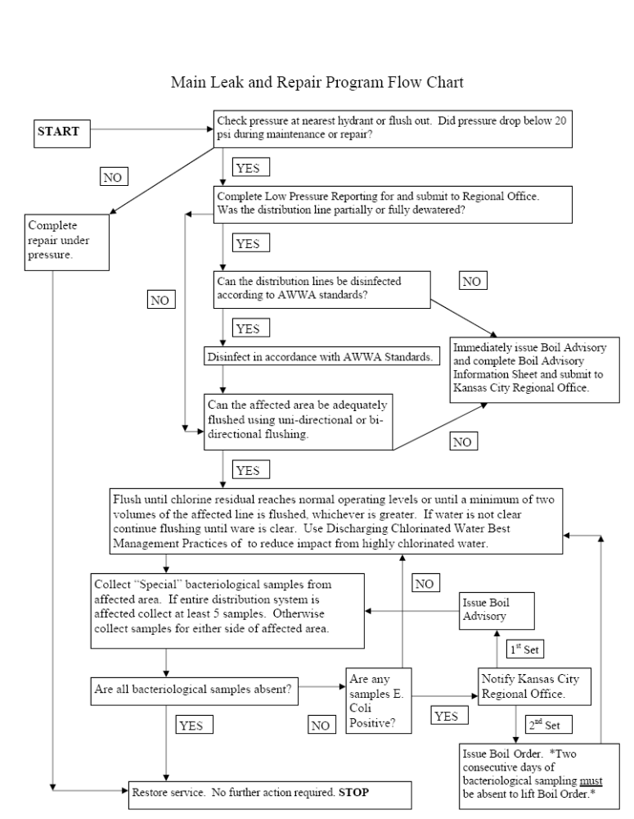

BOIL WATER ADVISORY INFORMATION

Water systems need to supply the following information to the Kansas City Regional Office when reporting the issuance of a boil water advisory. This sheet can be faxed to 816-622-7044 or the information conveyed over the phone 816-251-0700 to a Public Drinking Water Program staff member. After hours or on weekends and holidays use the Environmental Emergency Response hotline 573-634-2436.
Date: __________________________________ Time: ____________________________
Supply Name: ___________________________ ID #: ____________________________
County: ________________________________
Contact Person(s) Name & Daytime Phone #: ___________________________________
Reason for Advisory (Brief Description):_____________________________________
____________________________________________________________________________
_____________________________________________________________________________
_____________________________________________________________________________

Has problem been resolved? (If main break- what size, was it disinfected and flushed?):
_____________________________________________________________________________
____________________________________________________________________________

Brief Description of Service Area Affected & Names of any Priority Customers:
_____________________________________________________________________________
_____________________________________________________________________________
_____________________________________________________________________________
_____________________________________________________________________________

Method of customer notification (if by television, radio, or newspapers please provide specific names and city locations): _____________________________________________________________________________
_____________________________________________________________________________
_____________________________________________________________________________
_____________________________________________________________________________

Anticipated Number of days advisory will be in place:________________________
Number of samples that will be taken: _______________________________________
Location of samples that will be taken: _____________________________________
_____________________________________________________________________________
Name of testing lab:________________________________________________________

___________________________________________________________________________
REMEMBER TO CONTACT THE ______________ REGIONAL OFFICE WITH NOTIFICATION WHEN THE ADVISORY IS LIFTED AND PROVIDE COPIES OF THE BAC-T SAMPLE RESULTS.

 | MISSOURI DEPARTMENT OF NATURAL RESOURCES  WATER PROTECTION PROGRAM  PUBLIC DRINKING WATER BRANCH  REPORT OF LOW WATER PRESSURE |  |  |  |  | FOR OFFICE USE ONLY
 |  |  |  |  |  | DATE RECEIVED
Missouri Public Drinking Water Regulation 10CSR60-7.010(2) requires that public water systems notify the department within 48 hours of a failure to comply with any regulation or monitoring requirement. Since the regulation 10CSR60-4.080(9) requires all public water systems to maintain a minimum pressure of 20 psi, all public water systems must notify the department when pressures in their system fall below 20 psi.
Use this form to report low pressure events directly to the Department Regional Office in your area.
SYSTEM NAME |  |  |  | PWS ID# |  |  | COUNTY
REPORTED BY |  |  |  |  | DATE REPORTED (MM/DD/YYYY)
DESCRIBE NATURE OF PROBLEM
LOWEST PRESSURE READING (PSI) |  | DURATION OF LOW PRESSURE: ( HOURS/MINUTES) | DATE AND TIME OF PROBLEM ONSET |  |  |  |  | NUMBER OF SERVICES AFFECTED
LOCATION AND AREA AFFECTED
CORRECTIVE ACTION TAKEN
DATE AND TIME OF CUSTOMER NOTIFICATION
METHOD OF CUSTOMER NOTIFICATION (IF NOTICE WAS DONE BY HAND DELIVERY ATTACH A COPY OF THE NOTICE TO THIS SHEET)
I certify that I am familiar with the information contained in this application, and that to the best of my knowledge and belief such information is true, complete and accurate.
SIGNATURE |  |  |  |  |  |  |  |  | DATE
MAIL OR FAX COMPLETED COPY TO APPROPRIATE REGIONAL OFFICE:
ST. LOUIS REGIONAL OFFICE – 7545 S. Lindbergh, Ste 210, St. Louis, MO 63125; Phone 314-416-2960; FAX 314-416-2970
KANSAS CITY REGIONAL OFFICE – 500 NE Colbern Road, Lee’s Summit, MO 64086-4710; Phone 816-251-0700; FAX 816-622-7044
SOUTHWEST REGIONAL OFFICE – 2040 W. Woodland, Springfield, MO 65087-5912; Phone 417-891-4300; FAX 417-891-4399
SOUTHEAST REGIONAL OFFICE – 2155 N. Westwood Blvd., Poplar Bluff, MO 63901; Phone 573-840-9750; FAX 573-840-9754
NORTHEAST REGIONAL OFFICE – 1709 Prospect Drive, Macon, MO 63552-2602; Phone 660-385-8000; FAX 660-385-8090

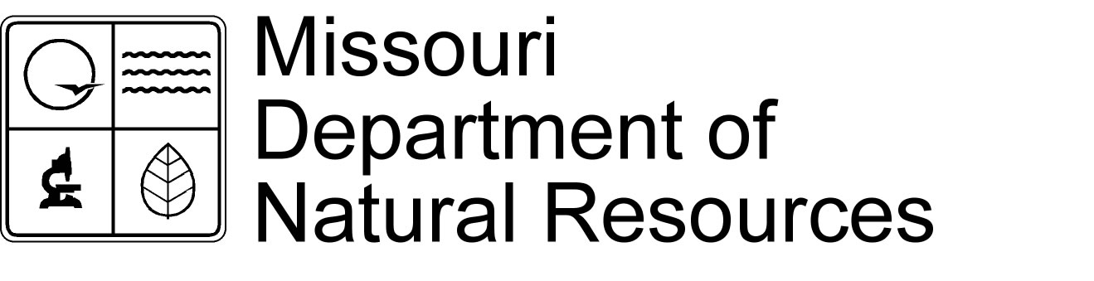

Repair and Disinfection of Water Mains

Draft technical bulletin 6/2008

Roughly 43% of the waterborne disease outbreaks in community public water systems in the United States are caused by distribution system deficiencies. Of these disease outbreaks 17% are caused by broken leaking water mains or contamination of water mains during construction or repair. Since some people estimate that only 19 or 20% of the waterborne disease outbreaks are reported and documented, the problem is huge. These disease outbreaks emphasize the importance of using proper procedures and methods when repairing water mains.

To prevent waterborne disease outbreaks, the Missouri Public Drinking Water Regulations 10 CSR 60-4.080(6) require that every supplier of water to a public water system must disinfect all newly constructed or repaired water distribution mains, finished water storage facilities or wells by methods acceptable to the Department before being placed in or returned to service. Failure to use acceptable methods is a violation of the regulations that could result in enforcement action. The Department accepts the methods presented in latest ANSI/AWWA Standard for Disinfecting Water Mains C651-05, which covers both the disinfection of new water mains and repairs of existing water mains. However, copies of the standard must be purchased consequently many operators do not have copies available for study and review. The following is a synopsis of the standard and covers some other practical issues of water main repair.

Many small water systems use backhoe or plumbing contractors to repair water mains and do not do the work themselves. Still, the water system officials are responsible for any work done in their water system even if it is done by a contractor. The chief operator of each system is in responsible charge and must oversee any repair work done to assure that the contractor uses the approved methods described below.

The first step is to locate the leak or repair area. Before starting work the area must be isolated to the fewest customers and the least number of water mains by locating and operating the appropriate main valves. Water pressures less than 20 psi are a health hazard because they can result in contamination of customer plumbing and the water mains. The larger the area affected the higher will be the probability that the water will be contaminated. Shutting off the well or water tower and putting the entire system out of water creates a health hazard for the entire community and is not a recommended practice even if a boil water notice is issued.

No amount of flushing, disinfecting or sampling of a main repair can make up for the unsanitary handling of materials or unsanitary practices during the repair. This starts with digging the repair trench. The trench must be dug on both sides of the main and be wide and long enough to accommodate a trench box and an access ladder. Trench boxes should be used when repairing leaks because the soil around the main is water soaked and unstable. Furthermore, most operators are not willing to slope trench walls at a 45° angle especially when digging in people’s yards or the street. Ladders should always be used to safely get in and out of trenches to prevent slips and falls. This also aids in handling repair fittings in a sanitary manner. The repair trench must be sized to allow the operator to safely work on the problem area with enough room to clean the repair area and to handle the repair materials in a sanitary manner. The trench must be dug out below the main deep enough for the repair clamp or other fittings to be installed without getting them into trench water or soil.

Proper handling of trench water is essential to repairing a main break in a sanitary manner. Studies done on water main breaks have shown that the trench water and soil is contaminated with total and Escherichia coliform and other bacteria. Therefore, it is essential that the trench water be removed from the pipe area to be repaired and that the repair clamp or other materials not come into contact with the trench water or soil while it is being installed. This requires that trench be dug deep enough to keep the water well below the pipe and that trench pumps are available that will successfully control the trench water. It may also be necessary to place gravel in the bottom of a trench to control the splashing of mud and water. If the capacity of a trench pump is inadequate, work should stop until additional or larger pumps are provided and the trench water is under control.

Before a repair clamp is installed on a pipe, the pipe must be cleaned of any soil and washed using clean rags and a 1 to 5 % bleach solution. When handling strong chlorine solutions appropriate safety practices should be followed to protect the operators. A several gallon plastic orchard sprayer filled with a bleach solution is the best way to provide an adequate amount of bleach for this purpose. Just before a repair clamp is installed on the pipe, the interior of both sides of the clamp must be cleaned and thoroughly sprayed with the bleach solution. Cleaning the repair clamp is easier if it is stored, hauled and handled in a sanitary manner before it is installed. Handling the clamp with clean hands or gloves and not setting it in dirt or mud is helpful. Also, preparing the clamp in a clean area as much as possible before taking it into the trench for installation is helpful. The same procedures must be followed when installing a tapping tee or saddle and include the tapping valve, pipe and other fittings installed and the tapping equipment.

The above procedures must be followed even if the main is repaired while it remains full of pressurized water and main pressures are kept above 20 psi. For systems that provide continuous disinfection and that maintain adequate disinfection residuals in the distribution system, leaks repaired under pressure present little danger of contamination and may not require disinfection after the repair. However, if a system does not provided continuous disinfection or if the main is not repaired under pressure disinfection is required.

If a main has to be cut open to repair it enough dirt must be removed to expose enough of each end of the pipe to adequately clean all areas that will come into contact with the repair fittings. The interior and exterior of each end must be cleaned of all soil and washed using clean rags and a 1 to 5 % bleach solution. If you can safely flush the strong chlorine solution from the affected area calcium hypochlorite tablets should be placed in the ends of the pipe. Before doing so, all service lines in the affected area should be turned off to prevent strongly chlorinated water from entering customer plumbing. To keep tablets in place that can be stuck to the pipe using a food grade adhesive. The following table shows the number of tablets required to disinfect pipe.

Table 1 Number of 5 gram calcium hypochlorite tablets required for a dose of 25 mg/l.
Pipe  Diameter | Length of Pipe in feet
Pipe  Diameter | 13 ft or less | 18 | 20 | 30 | 40
inches | Number of tablets
4 | 1 | 1 | 1 | 1 | 1
6 | 1 | 1 | 1 | 2 | 2
8 | 1 | 2 | 2 | 3 | 4
10 | 2 | 3 | 3 | 4 | 5
12 | 3 | 4 | 4 | 6 | 7
16 | 4 | 6 | 7 | 10 | 13

The interior of the couplings, repair pipe and other fittings installed must be cleaned and washed with a bleach solution just before installation. Depending on the length of the repair pipe a cloth swab soaked in bleach may be needed to clean and disinfect the interior of the pipe. Both exterior ends of the repair pipe must be cleaned and disinfected in the same manner as the water main ends. Care must be taken not to contaminate the couplings or repair pipe with soil or trench water during installation. The same procedures must be followed when replacing or installing a new valve elbow, hydrant or flushing device.

After the repair is installed the affected section of the main should be slowly filled with water to displace any air. If chlorine tablets were placed in the main it should be allowed to set several hours to allow the chlorine to dissolve and the repair to be disinfected. The amount of time required to disinfect the main depends upon the strength of the chlorine dosage. For example, if a 100 mg/l dose is used the time required is 3 hours. Then the chlorinated water should be flushed from the main and properly handled. Provisions to remove the strong chlorine from the water may be necessary. If chlorine tablets were not placed, the affected section of the main should be flushed at scouring velocities to remove any dirt or colored water and disinfected as described below. The following table shows the velocities that must be reached in water mains of different sizes to provide flushing velocities.

Table 2 Required flow of 2.5 ft/sec while maintaining a residual pressure of at least 20 psi.
Pipe Diameter | Flow in gallons per minute | Number of 2½ inch Hydrant Openings
2-inch | 26 gpm | 1
2½-inch | 38 gpm | 1
3-inch | 60 gpm | 1
4-inch | 105 gpm | 1
6-inch | 225 gpm | 1
8-inch | 400 gpm | 1
10-inch | 600 gpm | 1
12-inch | 900 gpm | 2
16-inch | 1,600 gpm | 2

After the repair is installed the affected section of the main should be flushed and chlorinated in the same way as a new water main. The AWWA standard says that this should be done where practical but the Department believes that not doing so should be the rare exception and not the norm. Furthermore it is not impractical just because the system or its contractor does not have the necessary equipment or does not want to make the effort to chlorinate and flush. Three methods of chlorinating a main are presented but two of these methods, using calcium hypochlorite tablets or granules, work only if the main was cut open to repair it. This guide will focus on the third method, the continuous feed method.

To use the continuous feed method the system or its contractor must have the equipment necessary to feed a chlorine solution into the water main. The basic equipment needed is a solution tank to hold the chlorine solution and a pump to pump the solution into the water main. The solution tank should be polyethylene with a tight fitting lid and valved fittings to connect the pump to the tank. The size of the tank depends upon the amount of water line to be disinfected but tanks larger than 50 gallons are difficult to move by hand. The size of the pump also depends on the amount of line to be disinfected but for most repair jobs a pump that will do less 5 gpm should be more than adequate. If an electric pump is used a portable power source must be available. The pump must include the hoses and fittings necessary to connect it to the solution tank and to the water main. A valve should be provided on the discharge side of the pump to control the pump output. The volume of solution to disinfect a water main is not large if it is injected directly into the water main as shown by the following table.

Table 3 Chlorine required to produce 25 mg/l concentration in 100 ft of pipe by diameter.
Pipe Diameter | 1 % Chlorine solution
inches | gallons
4 | 0.16
6 | 0.36
8 | 0.65
10 | 1.02
12 | 1.44
16 | 2.60

However, if an existing service line is used to inject the chlorine into the main the entire volume of the service line must be displaced to get the chlorine to the main. One hundred feet (100 ft) of ¾-inch diameter pipe contains 2.77 gallons of water and 100 feet of 1-inch diameter pipe contains 4.04 gallons of water. If the solution is pumped through a fire hydrant the entire volume of the fire hydrant and its leg line must be displaced to get chlorine to the main. Ten feet (10 ft) of 6-inch diameter pipe contains 14.7 gallons of water. If a service line or hydrant is not available, a tap should be made to the water main near the isolating valve upstream of the line break.

Before starting the chlorination process, all service lines in the affected area should be turned off to prevent strongly chlorinated water from entering customer plumbing. Once the chlorine source is connected to the water line the hydrant or flushing device downstream of the main repair should be opened and the isolating valve upstream from the repair opened partially to provide a low flow of water through main. At the same time pump chlorine solution into the main until at least a 25 mg/l residual is obtained at each hydrant or flushing device in the affected area. If there are multiple hydrants or flushing devices in the affected area they should be opened in succession until at least a 25 mg/l residual is obtained at each. Once the desired chlorine residual is obtained the hydrant(s) or flushing device(s) is shut off and the isolating valve is shut off. After 24 hours the chlorine residual in the main should not be less than 10 mg/l. If it is the chlorination process should be repeated.

Most water system operators do not want to wait 24 hours before restoring service to customers. Fortunately, the contact time required to disinfect a main can be reduced if the chlorine residual is increased. If the chlorine concentration is increased to 100 mg/l the contact time can be reduced to 3 hours. During the process the chlorine residual should not drop below 50 mg/l. If the dose is increased to 300 mg/l the contact time can be reduced to 15 minutes. However, methods must be provided to safely dispose of the very strongly chlorinated water.

After disinfection the affected area should be flushed to remove any colored water and until chlorine residuals are less than 4 mg/l then customer services can be turned on and the main returned to service. Because water pressures may have been less than 20 psi in customer premises, each affected customer should be notified that a main repair involving possible low water pressures has occurred and advised to flush all the plumbing in their premises before using any water. In addition, customers should be advised to boil water for drinking or culinary purposes and to notify the water system if they notice any color or odor other than chlorine in the water.

The customer advisory should not be lifted until special water samples are collect upstream and downstream of the main repair and are tested negative for coliform bacteria. If a large area of the system was affected more than two water samples may be required and the system should contact the appropriate Department regional office for guidance. If any sample tests positive for coliform bacteria the customer advisory must continue and additional disinfection and flushing is required. System operators should contact the appropriate Department regional office for guidance.

The Missouri Pubic Drinking Water Regulation 10 CSR 60-4.080(9) states that “Public water systems must maintain a minimum positive pressure of 20 psi throughout the distribution system under all normal operating conditions”. The Department concludes that water main leaks and repairs are normal operating conditions because of their frequent occurrence, because they are common to all water distribution systems and because locating leaks and repairing mains are routine duties for most water systems. Therefore, they are covered by the regulation. The Missouri Pubic Drinking Water Regulation 10 CSR 60-7.010(2) states “within 48 hours a supplier of water must report to the Department any failure to comply with any drinking water regulation”. This regulation is the legal basis for requiring water systems to report low pressure events to the Department. A form, Report of Low Water Pressure, is available from each regional office that can be filled out and faxed to that regional. Doing so will fulfill the system’s responsibility to report low pressure violations. The fax machines at each regional office operate 24 hours per day 7 days per week so the form can be faxed at any time any day.

 | DISCHARGING CHLORINATED WATER  BEST MANAGEMENT PRACTICES

The objective of disinfection and flushing programs is to maintain a high level of water quality delivered to customers. The Department of Natural Resources Public Drinking Water Branch encourages public water systems to conduct routine water main flushing, particularly on those water mains that do not receive enough water demand to scour the pipe surface or maintain chlorine residual. Unfortunately, discharging large volumes of chlorinated water may have adverse effects on property owners and the environment.
Flushing occurs when new facilities are installed as well as on a routine basis to maintain existing facilities. Flushing disinfected water from treatment, storage, and distribution facilities may have serious consequences on the environment receiving the discharged chlorinated water.
Moderate levels of chlorine in streams and lakes can be detrimental to aquatic life.
The Missouri Clean Water Commission Regulation 10 CSR 20-2.010(22) defines a discharge as the causing or permitting of one or more water contaminants to enter waters of the state. Chlorine has specific limits for discharge into water of the state (10 CSR 20-7.031 Table A). A typical maximum concentration of chlorine that may be discharged to waters of the stated is 0.02 milligrams per liter (mg/l). Specific limits for chlorine discharges should be provided by the Missouri Department of Natural Resources Water Pollution Control Program.
It is important for public water systems to know that discharging contaminant to water of the state is a violation of the Missouri Clean Water Commission Regulations and may result in fish kills. Although flushing procedures do not require a permit from the Department, fish kills are enforceable offences that may be pursued by the Water Pollution Control Program. Therefore, system operators and contractors discharging chlorinated water must consider the receiving environment.
Please understand that very few discharges from routine water main flushes require dechlorination when best management practices are used as referenced in item number two below. The following items should be considered when discharging chlorinated water:
1. If disposing of heavily chlorinated water, inspect the environment to which the water will be discharged in accordance with American Water Works Association (AWWA) Standard C651-99, Sec. 4.5.2. "Disposing of Heavily Chlorinated Water".
2. Determine the impact of the discharge to the environment. If the water to be discharged has low levels of chlorine and will not reach the waters of the state, dechlorination may not be necessary.
3. If it is determined to be necessary, dechlorinate in accordance with AWWA Standard C652 Disinfection of Water Storage Facilities Appendix B or as prescribed by your operations professional.
4. Avoid over chlorinated or over applying disinfectants when disinfection. AWWA Standard C651 Disinfecting Water Mains Appendix B contains recommended amounts of chemicals to produce various chlorine concentrations.
5. Contractors need to follow the best management practices for discharging chlorinated water and the applicable flushing procedures established by the public water supply.
6. Flushing procedures and dechlorination must be considered during the design of large water mains and storage facilities.
7. Develop a water main flushing program and maintain a flushing manual for the public water supply. Identify the necessary equipment, chemicals, and retention tanks needed for routine flushing procedures within this manual.
8. If possible, spray the interior of the tanks with a chlorine solution to reduce the volume of water to dechlorinate.
9. When possible, divert flush water from storm drains and ditches. If flush water is to enter a combined sewer, the receiving wastewater treatment facilities must be considered.
10. Avoid personal property damage, which includes flooding basement and yards to washing out lawns and flower beds.
11. Be aware of possible ice hazards on streets, sidewalks, and driveways when flushing during winter months.
It is important to remember that each flushing scenario is unique because of three factors. The first factor is the volume of water to be discharged. The second factor is the amount of disinfectant in the water to be discharged. And the final factor is the downstream environment that may be affected. It is the responsibility of each public water supply to prevent contamination of the waters of the state and to protect not only public health and our water systems but also our environment.
1. Check with local sewer department for conditions of disposal to sanitary sewer, and with the state regulatory agency for conditions of disposal to natural drainage courses.
2. Chlorine residual of disposed water will be neutralized by treating with one of the
chemicals listed in Appendix Table B.

This appendix is for information only and is not a part of AWWA C652.

Table B. Amounts of chemicals required to neutralize various residual chlorine
concentrations in 100,000 gal (378.5 m3) of water
 | Chemical Required
Residual  Chlorine  Level | Sulfur Dioxide  (SO2) |  | Sodium Bisulfite  (NaHSO3) |  | Sodium Sulfite  (Na2SO3) |  |  | Sodium Thiosulfate  (Na2S2O35H2O) |  | Ascorbic Acid**  (Vitamin C)
mg/L | lb. | (kg) | lb. | (kg) | lb. | (kg) | lb. |  | (kg) | lb. | (kg)
1 | 0.8 | (0.36) | 1.2 | (0.54) | 1.4 | (0.64) | 1.2 |  | (0.54) | 1.8 | (0.82)
2 | 1.7 | (0.77) | 2.5 | (1.13) | 2.9 | (1.32) | 2.4 |  | (1.09) | 3.86 | (1.75)
10 | 8.3 | (3.76) | 12.5 | (5.67) | 14.6 | (6.62) | 12.0 |  | (5.44) | 19 | (8.5)
50 | 41.7 | (18.91) | 62.6 | (28.39) | 73.0 | (33.11) | 60.0 |  | (27.22) | 95 | (43)
** Values for Ascorbic Acid are calculated, and were not field tested.

