Utility Information

Service Address ___________________________________________________

Are you the: Owner Tenant Property Manager Other

Your Name _______________________________________________________

Phone Number (optional) ____________________________________________

Email Address (optional) ____________________________________________
May we add your contact information to our customer database? Yes No

Is this a residence, business, barn, or other structure?
Please indicate other structure_______________________________________

What year were the water lines established in the structure, if known.______________

Service line material at the point of entry (inlet) to your home?

Lead Copper Galvanized Other (Plastic/PVC/Pex/etc.)

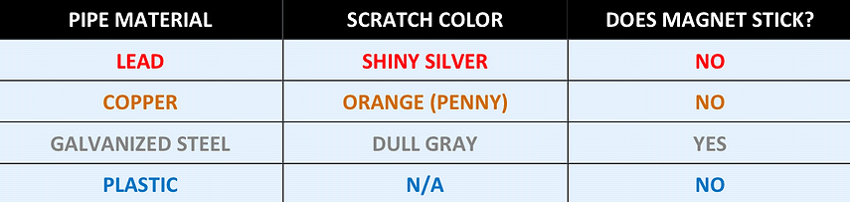
Has the line from the water meter to your home/facility been replaced?

Yes No
If yes, please provide the date and material used for replacement.

Optional – please email a photo of the water line entering your home from the meter to: Inventory@system.com (example)

Please contact the city/district/utility office if you need assistance with this request.
Contact information - email and phone

Thank you for helping our utility meet compliance with the EPA regulation.

